**Defining your style**

It is important to make sure that the visual style of your site remains consistent and matches your site goal. One you have your wireframes completed it is time to start working on this visual design, Here are some things to keep in mind.

**Branding**

As you produce your website you need to remember that what you are doing is branding yourself. The quality of the design of your site is just as important as the quality of the work that it displays. From the logo to the spelling, everything about this site will define who you are and how much attention/pride you take in your work.

**Color**

At this point you should have a strong grasp on Color Theory, and be able to choose a set of harmonious colors that will work with your vision / goal. How you use color is just as important as which colors you choose.

**Texture**

To texture or not to texture? Some people go for the minimal look by only using HEX based color for their backgrounds arguing that it speeds up their access time. While this is a valid argument, it does not really address the goal of the site. It is possible to create small transparent texture tiles that can overlay any background color and upgrade the look of the site with minimal download time.

* <http://designfestival.com/the-cicada-principle-and-why-it-matters-to-web-designers/>

**Typography**

Wordpress uses a lot of text; menus, taglines, side bars, content, etc.. Because there is so much tech you should spend some time thinking about how you want this text to be displayed. Font stacks, line-height, color, hover states; all of this has an effect on how the viewer interacts and responds to your design.

Two of the most important aspects to consider are font face and vertical rhythm. I will be showing you how to install and serve your own custom typeface using the @font-face rule in CSS3. You can search for @font-face kits. The most popular site is fontsquirrel.com with a bunch of pre-made kits, if you have a font that is opensource, fontsquirrel will generate all the fonts and css you need.

Vertical rhythm is about how your fonts line up on a vertical grid. This is tricky to accomplish on the web, even for seasoned professionals. Luckily there are some online calculators that make this easy...

**Vertical Rhythm Calculators**

* <http://lamb.cc/typograph/>
* <http://drewish.com/tools/vertical-rhythm>
* <http://topfunky.com/baseline-rhythm-calculator>
* <http://www.gridlover.net/>

**More Resources:**

* <http://net.tutsplus.com/tutorials/html-css-techniques/six-ways-to-improve-your-web-typography/>
* <http://www.smashingmagazine.com/2009/01/27/css-typographic-tools-and-techniques/>
* <http://type-a-file.com/>

**Visual Style**

Color Texture and Typography all combine to create your visual style. How will you apply these to your page elements? What is the overall concept of your design? And how do these combine to make a cohesive whole?

With typography we discussed vertical rhythm. When you convert your wireframes into design comps you need to consider horizontal rhythm or column layout. A lot of web designers use The Golden Ratio (Wicked WordPress Themes, p. 39).

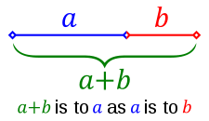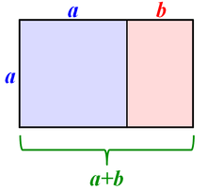

This method has been used since Pythagoras and Euclid in ancient Greece and plays off the basic ratios as seen in nature.

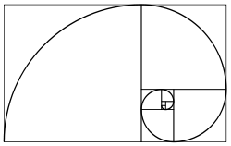

There is a css framework that builds upon this called *The Golden Grid* (<http://code.google.com/p/the-golden-grid/> ) than can help you maintain the aspect ratio in your column and typographical layout.

One good way to get started on your comps is to find a theme that you will be revising or using as your framework ,and edit the css to remove all colors and imagery. Make sure all text is black and all background colors are white and add a 1px black stroke to all the main sections. Then using a plugin for firefox like ScreenGrab (http://www.screengrab.org/) you can create an image of the entire page (even the non visible area) that you can then bring into the image editing software of you preference to use a a template to design upon.